*Module 7 Network fundamentals*

Advance Question

1. **Explain Network Topologies**

* A network topology is the physical and logical arrangement of nodes and connections in a network. Nodes usually include devices such as switches, routers and software with switch and router features. Network topologies are often represented as a graph.

1. **Explain TCP/IP Networking Model**

* TCP/IP is a data link protocol used on the internet to let computers and other devices send and receive data.

1. **Explain LAN and WAN Network**

* LANs connect users and applications in close geographical proximity same building. WANs connect users and applications in geographically dispersed locations across the globe.

1. **Explain Operation of Switch**

* Switches may be operated by process variables such as pressure, temperature, flow, current, voltage, and force, acting as sensors in a process and used to automatically control a system.

1. **Describe the purpose and functions of various network devices**

* Router: The routers are used to create internetworks. They use routing tables or map of the internetworks to make path selection and send data packets to other networks.

Hubs: Hubs operate on the same network segment they cannot divide a network.

Bridge: A Bridge has just 2 interface devices.

1. **Make list of the appropriate media, cables, ports, and connectors to connect switches to other**

* Ethernet cables, RJ45, Trunk, Hybrid, Combo port, Stack port, PoE port, Access

1. **Define Network devices and hosts**

* A network node is any device participating in a network. A host is a node that participates in user applications, either as a server, client, or both.

1. **What are Ethernet Standard (802.3) and Frame Formats?**

* The IEEE 802.3 standard defines the fundamental frame format that is necessary for all MAC implementations.

Intermediate Question

1. **Comparison between UTP, MM and SM Ethernet Cabling**

* UTP is a cable with wires that are twisted together to reduce noise generated by an external source. On the other hand, Single-mode fibers have a higher bandwidth capability than multimode fibers due to no modal dispersion effects, which means that they can transmit larger amounts of data over great distances.

1. **Make Cross cable**

* Done

1. **Make Straight-Through Cable**

* Done

1. **Differentiate between LAN/WAN operation and features**

* LANs use local connections like ethernet cables and wireless access points. WANs use wide area connections like MPLS, VPNs, leased lines, and the cloud.

1. **Explain ARP, ICMP and Domain name**

* ARP is used to resolve IP addresses to MAC addresses for communication on the local network, and ICMP provides feedback about the status of the network.

1. **Describe the components required for network and Internet communications**

* Router switch hub server modem cable bridge

1. **Explain Encapsulation and DE capsulation in OSI Reference model**

* Encapsulation adds information to a packet as it travels to its destination. Decapsulation reverses the process by removing the info, so a destination device can read the original data.

1. **Explain network segmentation and basic traffic management concepts**

* Network segmentation divides a network into multiple zones and manages each zone, or segment, individually.

1. **What is flow control and acknowledgment?**

* The purpose of flow control is to throttle the amount of data transmitted to avoid overwhelming the receiver's resources. This is accomplished through a series of messages that the receiver transmits to the sender to acknowledge if frames have been received.

Advance question

1. **Use the OSI and TCP/IP models and their associated protocols to explain how data Flows in a network**

* TCP/IP is a practical model that addresses specific communication challenges and relies on standardized protocols. In contrast, OSI serves as a comprehensive, protocol-independent framework designed to encompass various network communication methods.

1. **Identify and explain at layers 1, 2, 3, and 7 using a layered model approach**

* Layer 1 is the physical layer. It is responsible for the actual physical connection between the devices. The physical layer contains information in the form of bits.

Layer 2 the data link layer is responsible for the node-to-node delivery of the message.

1. **Explain CSMA/CD and CSMA/CA**

* The CSMA/CD type is utilized to identify a shared channel collision. It's a mechanism for detecting collisions and works with both wired and wireless networks. While CSMA/CA is used to keep a shared channel free of collision. And it's a mechanism for avoiding collisions and can connect to wireless networks.

1. **Explain this frame and find layer**

* Frames are the result of the final layer of encapsulation before the data is transmitted over the physical layer.

1. **Draw and explain Cisco hierarchical model**

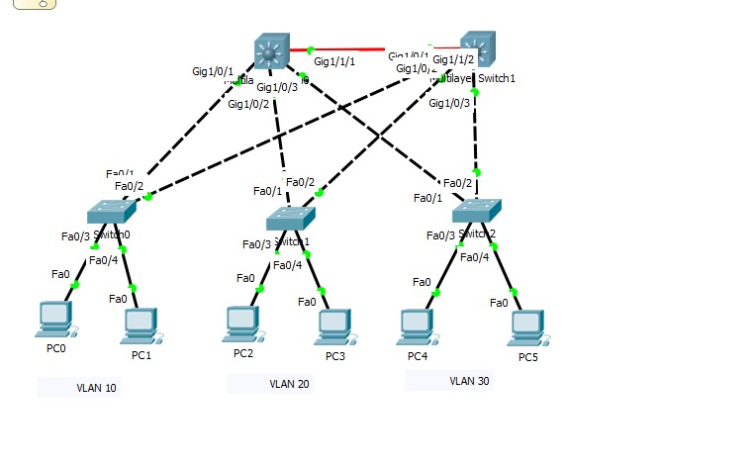

1. **Drawing of a typical wired and wireless enterprise LAN**

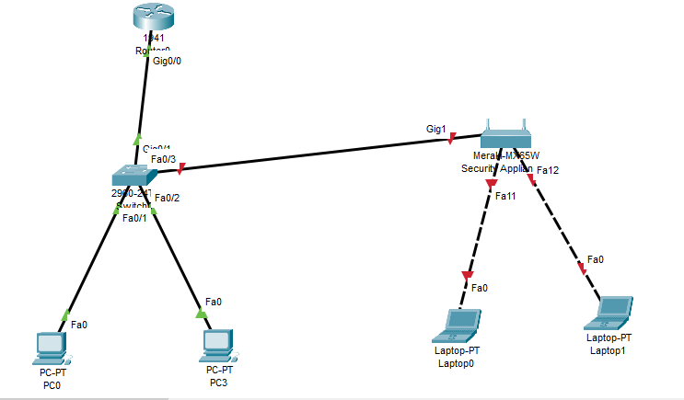

1. **Describe the uses of straight-through and crossover Ethernet cables**

* You should use straight-through cable when you want to connect two devices of different types. You should use a crossover cable when you want to connect two devices of the same type.

1. **Explain Layer 2 and Layer 3 Switch**

* Layer 2 switches are often used to reduce data traffic on a LAN. Because they use MAC addresses only, an unidentified device attempting to use the network will be denied. On the other hand, Layer 3 switches are primarily used to operate VLANs and improve security.

1. **Identifying Collision and Broadcast Domains**

* In a collision domain, the information sent from one device could collide with the information sent from another. In a broadcast domain, the information sent to one device is kept separate from the information sent to another.

1. **Explain Spanning Tree Protocol**

* Spanning Tree Protocol (STP) is a Layer 2 protocol that runs on bridges and switches. The specification for STP is IEEE 802.1D.

1. **Explain uncast Multicast and Broadcast**

* Unicast is a one-to-one data transmission method. Broadcast is a one-to-many data transmission method. Multicast is a many-to-many data transmission method. One-to-one mapping.

1. **Explain CAM (Content Addressable Memory)**

* Content-addressable memory (CAM) is a special type of computer memory used in certain very-high-speed searching applications.

1. **Explain CAM (Ternary Content Addressable Memory)**

* Ternary content-addressable memory (TCAM) is a specialized type of high-speed memory that searches its entire contents in a single clock cycle.

**14.Which command use of Show MAC TABLE?**

* Get mac-address